

**English Literature**

**Circus Elephant**

**Name:___________________________ Std:___ Div:__Roll No:___**

**Ex 1. Look at the given pictures and answer the following questions.**

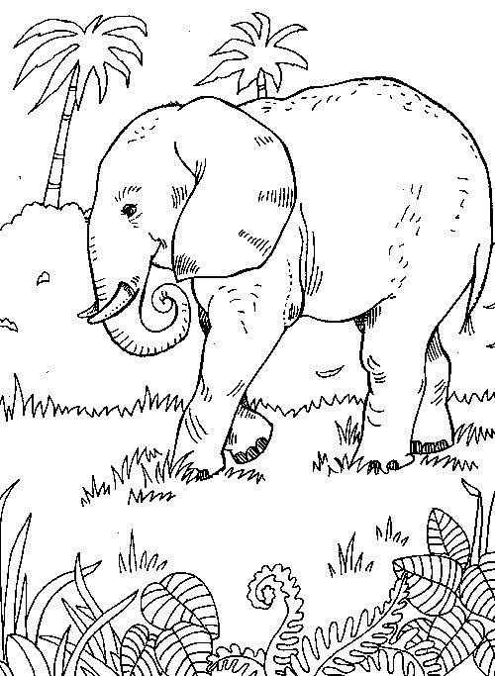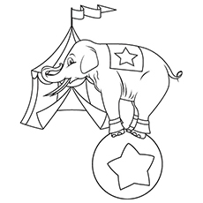**JUMBO PAST**

Q1. Where is the elephant in the first picture?

A._______________________________________________________________

Q2. Where was he taken away from?

A.________________________________________________________________

_________________________________________________________________

Q3. What if you were asked to perform in a circus like Jumbo the elephant would

it make you happy? Justify your answer in one sentence.

A._______________________________________________________________

________________________________________________________________

________________________________________________________________

________________________________________________________________

Q4. Which word did the poet use for the elephant? Why?

1. _______________________________________________________________

_______________________________________________________________

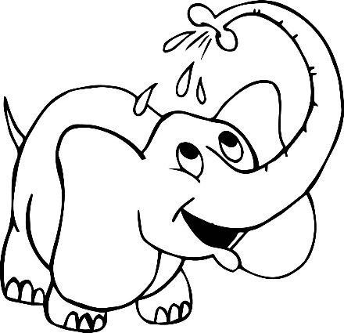**Do you think Jumbo the elephant remembers anything from his past? Help him**

**remember the long gone days by naming the animal and filling the boxes with the missing alphabets.**

1. The cry of a hungry beast.

P

1. The animal at his feast.

N

1. The thunder of the animal feet.

E

1. The long forgotten music

S

**In the given box write a message for your siblings how they must treat animals**